**Faculty Information Form-2016**

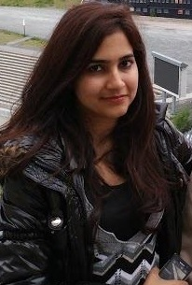

**Name: Ayesha Syed**

**_____________________________________________________________________________________**

**Title/Designation: Teaching Fellow**

**_____________________________________________________________________________________**

**Research Interests: Democracy and voting theory**

**_____________________________________________________________________________________**

**Publications:**

**AGGREGATION METHODS FOR FUZZY JUDGMENTS, fuzzy economic review (forth coming**)

**____________________________________________________________________________________**

**Degrees:**

**Mphill- Economics, Lahore School of Economics, Pakistan**

**B.Sc. Hons, Major in Economics and Minor Math and Stats, Lahore School of Economics, Pakistan**

**_____________________________________________________________________________________**

**Email: ayeshasyed66@gmail.com**

**____________________________________________________________________________________**

**Tel: 03234033594**

**_____________________________________________________________________________________**

**Conferences Attended: 8th Annual American Business Research Conference-2016**